Module 09 – Fixed Charge Problem

Model Formulation

*Write the formulation of the model into here prior to implementing it in your Excel model. Be explicit with the definition of the decision variables, objective function, and constraints* Exploratory Data Analysis

*In this section, you should perform some data analysis on the data provided to you. Please format your findings in a visually pleasing way and please be sure to include these cuts:*

* *Make a visual graph of your data on a map (coordinates should be within US borders)*
  + <https://mymaps.google.com/>
  + Find a map with latitude/longitude and place them approximately
  + Any alternative that gives the same effect

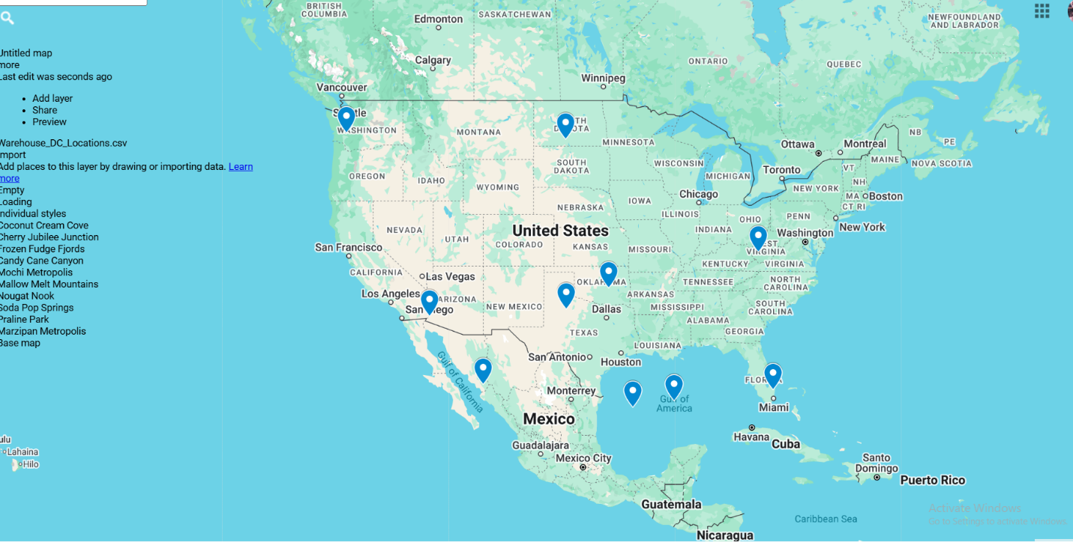

*.*

Model Optimized for Min Costs to Supply DCs

*Implement your formulation into Excel and be sure to make it neat. This section should include:*

* *A screenshot of your optimized final model (formatted nicely, of course)*
* *A text explanation of what your model is recommending*

All distribution center demands are fully satisfied while adhering to the 2-warehouse limit. This result aligns well with our goal to minimize operational costs while maintaining service coverage.

Model with Stipulation

*Please copy the tab of your original model before continuing with the next part to avoid messing up your original solution.*

*Please perform 2 out of the 3 scenarios below with a short text description on what changed:*

1. *Instead of only being able to open 2 warehouses, what happens to our objective function when we only can open 1 warehouse?*

The model now selects a centralized warehouse ,Frozen Fudge Fjords

Total cost increases significantly because a single warehouse must serve all DCs, even the ones far away.

Distribution assignments shift entirely to that one location.

Restricting the solution to only one warehouse sacrifices cost efficiency. While simpler logistically it leads to higher shipping costs due to less geographic coverage.

1. *Right now, we have $1 per unit shipped over the distance between the warehouse and the DC. What happens to our objective function when we increase this to $30? Does your DC assignment change at all?*

Restricting the solution to only one warehouse sacrifices cost efficiency. While simpler logistically, it leads to higher shipping costs due to less geographic coverage

1. *For distance between each location, we used Manhattan distance but what happens to our model if we use Euclidean distance instead? Did the change impact the model at all? Do you feel this is a better distance metric to use in this scenario?*

Euclidean distance is a better metric when transportation routes approximate straight-line paths. It provides a more realistic cost measure than Manhattan in open terrains.

